The smallest known non-avian theropod dinosaur

Xing Xu, Zhouhe Zhou, Xiaolin Wang

The Institute of Vertebrate Paleontology and Paleoanthropology, Chinese Academy of Sciences, P. O. Box 643, Beijing 100044, People's Republic of China

Cladistic Analysis. List of 89 characters and data matrix informative for resolving the phylogenetic relationships of the taxa in Figure 3. Characters 1-86 are derived from Xu et al. (1999); characters 87-89 are newly added in this study. The numbers in square brackets “ [ ] “ represents the original character numbers in Xu et al (1999).

Character list

Characters from Xu et al. (1999)

- [2] Denticles on teeth: present on anterior and posterior carinae (0); present on posterior carina, absent on anterior carina (1); absent on both carinae (2) (modified)
- [3] Shape of teeth: all teeth laterally compressed and recurved (0); anterior teeth laterally compressed but posterior teeth slightly compressed, nearly conical (1); all teeth slightly compressed, and nearly conical (2) (modified)
- [4] Constriction between crown to root: absent on all teeth (0); absent on anterior teeth but present on posterior teeth (1); present on all teeth (2) (modified)
- [6] Maxilla contribution to naris: absent, excluded by a nasal-premaxilla contact (0); present (1)
- [7] Shape of frontals: anteriorly broad (0); triangular, narrow rostrally (1)
- [8] Extreme reduction or loss of prefrontal: absent (0); present (1)
- [9] Frontal length relative to parietal: smaller or subequal (0); nearly two times as long (1)
- [10] Narrow sagittal crest on parietals: absent (0); present (1) .
- [11] Jugal bar shape: robust (0); thin and straight (1)
- [14] Distal quadrate articulation set well anterior to proximal quadrate cotyle: absent (0); present (1)
- [15] Shape of parocipital process: straight and vertically oriented (0); distal end with distinct twist as to face caudodorsally (1).
- [16] Bulbous parasphenoid capsule (cultriform process): absent (0); present (1)
- [17] Accessory lachrymal fenestration: present (0); absent (1)
- [19] Fusion between parietals and laterosphenoid in adults: present (0); absent (1)
- [22] Interdental palates: present (0); present, fused (1); absent (2).
- [24] Ventral processes (hypopophyses ) on cervicodorsal vertebrae: absent or very weakly developed (0), present, well developed (1)
- [26] Pneumatic foramen on dorsal vertebrae: present (0); absent (1)
- [27] Number of sacral vertebrae: 5 or less (0), 6 or more (1)
- [28] Fusion of all sacral vertebrae in adult: absent or partially fused (0); present, all completely fused (1)
- [29] Number of caudal vertebrae: 30 or more (0), 20-25 (1), or less than 15 (2)
- [30] Transition point on caudal vertebrae: distal, behind caudal 10(0); proximal, no further back than caudal 10 (1)
- [31] Middle and distal chevron shape: laterally compressed, expanded dorsoventrally (0); dorsoventrally flattened into a thin horizontal plate behind transition point (1)
- [34] Length of middle and posterior caudal vertebrae: subequal to length of proximal caudals (0); elongate, at least 130% the length of the anterior caudals (1)
- [35] Prezygapophyses on middle and posterior caudal vertebrae: elongate, extend at least half the way across preceding vertebral centrum (0); reduced or absent, extend over 25% or less the length of preceding vertebral centrum (1)
- [36] Anterior projection of acromion process: absent (0); present, extends well anterior to glenoid fossa (1)
- [39] Body of coracoid forming sharp angle with the body of scapula: absent (0); present (1).
- [40] Coracoid shape: short, rounded sternal border (0); elongate, subrectangular profile, rounded sternal border (1); elongate, strut-like (2)
- [41] Shape of fused clavicles: absent (0); present, interclavicular angle greater than 90 degrees (1); present, interclavicular angle less than 90 degrees (2)
- [42] Ossified sternum: paired (0); fused or partially fused into a single structure (1); fused with a midline keel
- [43] Distal condyles of humerus located mainly on the distal (0), or cranial (1), aspect.
- [44] Ratio of diameter of shaft of radius to ulna: more than 0.7(0); thinner than ulna, less than 0.7 (1).
- [45] Metacarpal I greater than (0), or less than (1) one-third the length of MC II
- [46] Metacarpal III: straight (0); bowed laterally (1)
- [47] Combined lengths III-1 and III-2 relative to II-3 on manus: longer (0); subequal (1); absent (2)
- [48] Forelimb elongation relative to presacral length: less than one half presacral length (0); 60-90% presacral length (1); more than 100% presacral length (2)
- [49] Manus length relative to ulna length: manus shorter than or subequal to ulna (0) ; manus longer than ulna by at lest 20% (1)
- [50] Ulnar distal condyle: transversely compressed and craniocaudally extended proximally in the same plane as the humero-ulnar flexion-extension movement (0); subtriangular in shape in distal view, with a dorsomedial condyle, and twisted more than 54 degrees with respect to the proximal end (1)
- [51] Shape of ulnar posterior margin: sigmoid (0); uniformly convex (1)
- [53] Length of preacetabular process of ilium relative to length of postacetabular process: subequal (0); twice as long (1).
- [54] Postacetabular process depth: relatively deep, more than 50% depth a acetabulum (0); shallow, less than 50% depth at acetabulum, drawn back into a low, pointed process (1)
- [56] Tubercle on dorsal margin of ilium above caudal acetabulum: absent (0); present (1)
- [57] Craniocaudal width of pubic peduncle on ilium relative to width of acetabulum: narrow, less than acetabular width (0); wide, exceeds acetabulum in width (1)
- [58] Pubic foot: projects cranially and caudally (0); projects caudally only (1); absent (2)
- [59] Angle of pubic shaft relative to the long axis of sacral vertebrae: projects cranially (0); subvertical (1); projects caudally(opisthopubic )(2)
- [60] Ratio of length of ischium to length of pubis: more than 0.66 (0), between 0.66 - 0.51 (1); less than 0.5 (2).
- [62] Placement of obturator process: proximal (0); mid-shaft (1) ; distal (2)
- [63] ‘Postacetabular” process on proximal ischium behind iliac contact: absent (0); present, nearly contacts postacetabular process of ilium (1)
- [64] Process on caudal border of midshaft of ischium: absent (0); present (1)
- [65] Shape of ischial shaft: rod-like in part with a circular or subcircular cross section (0); mediolaterally compressed and plate-like along entire length (1)
- [66] Postacetabular blade on ilium: brevis shelf caudolaterally oriented, medial flange ventrally curved (0); postacetabular blade vertical, medial flange strongly reduced and perpendicular to iliac blade (1)
- [67] Configuration of lesser trochanters: large and flange-like, separated from femoral shaft, head, and greater trochanter by a deep cleft (0); nearly confluent with the greater trochanter, and separated from the proximal head of femur by only a small cleft or groove (1); joined to greater trochanter to from an undivided trochanteric crest, proximal articular surface confluent with that of femoral head (2)
- [69] "Posterior trochanter" on femur: absent (0); present, cranially placed (1);; present, centered on the trochanteric crest (2).
- [70] Femoral neck: present, constriction developed that separates trochanteric region from femoral head (0); absent (1)
- [71] Proximal tibia: craniocaudal length twice that of mediolateral width (0); length and width of proximal tibia subequal (1)
- [72] Midshaft diameter of fibula relative to tibia: approximately one-fifth or more that of tibia (0); one-fifth or less that of tibia (1)
- [73] Orientation of ilofibularis tubercle on fibula: craniolateral (0); lateral (1); caudolateral or caudal (2)
- [76] Fusion of proximal tarsals to crus: absent (0); present, partially fused (1); present, completely fused (2)
- [77] Fusion of astragalus to calcaneum in adults: absent (0); present, partial to complete (1)
- [79] Position of pes digit I: parallel to other digits (0); reversed to oppose other digits (1)
- [80] Relative contributions of metatarsals II, III, and IV to ankle joint: all contribute approximately equally (0); partially or completely arctometatarsalian, MTIII is nearly or completely eliminated from joint (1)
- [81] Relative size of pedal digit II: phalanges and ungual subequal in size and robustness to digits II and IV (0); developed into a robust, hyperextensible slashing digit with the enlarged sickle-like ungual subequal (1)
- [82] Ratio of length of tibia to length of femur : tibia no more than 15% than femur (0); tibia elongate, at least 25% longer than femur (1).
- [83] Frontal anterior demarcation of supratemporal fossa: straight or slightly sinuous(0) sinusoidal with associated deep pit (1)
- [84] Teeth: secondary premaxillary tooth: smaller than or equal in size to third and fourth premaxillary teeth (0); significantly larger than premaxillary teeth 3 and 4 (1)
- [85] Teeth: maxillary, mandibular: anterior and posterior denticles not significantly different in size (0); anterior denticles, when present, significantly smaller than posterior denticles (1).
- [86] Lacrimal: inverted L-shaped (0); T-shaped (1).
- [87] Frontal, lacrimal-prefrontal contacts: sutures on lateral dorsal and /or ventral surfaces (0); dorsal ventral surfaces connected by a vertical slot (1)
- [88] Supratemporal fossa: limited extension onto dorsal surfaces of postorbital and frontal (0); covers most of frontal process of postorbital and extends anteriorly on dorsal surface of frontal to at least level of the posterior orbital margin (1)
- [89] Postorbital: T-shaped (0); upturned frontal process 91).
- [90] Quadratojugal: L-shaped (0); Y-or T-shaped (1)
- [91] Quadratojugal fenestra: small foramen-like opening (0); widely open (1)
- [92] External auditory meatus: does not extend beyond level of intertemporal bar of postorbital and squamosal (0); ventral process of squamosal and lateral extension of paroccipital process beyond head of quadrate (1)
- [93] Opisthotic-exoccipital: no periotic pneumatophore or pneumatized paroccipital process (0); periotic pneumatophore enters hollow paroccipital process (1).
- [94] Pterygoid flange: includes major contribution from pterygoid (0); is formed mostly by ectopterygoid (1).
- [95] Dentary: thick when compared to height, deep Meckelian groove, pronounced dental shelf (0); thin and high with shallow Meckelian groove and dental shelf (1)
- [96] Dentary; lateral view: tapers conspicuously anteriorly (0); upper and ventral margins subparallel (1)
- [97] Splenial: limited or no exposure of splenial on lateral surface of mandible (0); conspicuous triangular process on external surface of mandible between dentary and angular (1).
- [98] Internal mandibular fenestra: absent or small and slit-like (0); triangular and relatively large (1)
- [99] Ventral columnar process of retroarticular process: absent (0) present (1)
- [100] Ossified caudal rods extending lengths of prezygapophyses and chevrons: absent (0); present (1)
- [101] Frontal process of premaxilla: short (0), relatively long to very long, at least approaching the rostral border of the antorbital fossa (1).
- [102] Caudal margin of naris farther rostral than (0), or nearly reaching or overlapping (1), the rostral border of the antorbital fossa.
- [103] Scapula: longer (0), shorter (1), much shorter (less than 2/3) (2) than ulna
- [104] Ulna subequal to or shorter than (0), longer than (1) metatarsal III (modified).
- [105] Glenoid of pectoral girdle: facing posteroventrally or posterolaterally (0); facing laterally (1)
- [106] Articular facet of coracoid on sternum (conditions may be determined by the articular facet on coracoid in taxa without ossified sternum ): anterolateral or more lateral than anterior (0); almost anterior (1)

Characters newly added in this study

- A longitudinal ridge along the postomedial surface of metatarsal IV absent (0); present (1)
- Metatarsal IV subequal to II in robustness (0); apparently more robust than II (1)
- Second pedal claw subequal to or smaller than (0); apparently larger than the pedal phalanx II-1 (1)

Matrix

Allosaurus
0000000000 0000000000 0000000000 0000000000 0000000000 0000000000 0000000000 0000000000 000000000
Compsognathus
000000001? 0?10000??0 ?00?000??0 00??000?00 ?1?010?00? ?????00?00 0100000?00 0???000000 000000?00
Archaeopteryx
2221011110 1?10001001 1111111111 1111211111 1111221111 11111?1110 0100000000 0110000000 112111?00
Rahonavis
?????????? ?????1111? 11111????? 1???2?1111 1111221111 2211120110 11???????? ?????????0 ??211?000
Oviraptoridae
???1010110 0000211100 0001000110 0000100000 0000010000 1000000000 0100000000 0000000000 1100000?0
Velociraptorinae
00000?1101 0000211100 11100?1101 0111100100 0121210011 1100000000 1011111111 1111111111 001111101
Dromaeosaurus
000001??01 10101????? ?????????? ?????????? ?????????? ?????????? 1?00011111 111111111? 00????101
Ornithomimidae
2021101011 0110200000 0000000000 0001100000 0000110000 1000000001 0000000000 0000000000 000000000
Troodontidae
??2111110? 0111210100 11100000?1 1101110100 ??20210001 1200011101 1100000000 0000001000 00?000010
Protarchaeopteryx
022????00? ????0?1??1 1?1???110? 11?1110?00 ?01?????00 1??00?0000 01?00????? 0????????0 0??0???00
Caudipteryx
22011?000? ????0??0?1 110??0110? 11??100?00 ?01???0000 12?0??0000 0100?0??00 0???00???0 110000000
Sinornithosaurus
000?0011?? ?01?01?00? ?11011110? 1111?1??0? ?12122011? ?1??1?0111 1?11110101 1???011??1 001111111
Microraptor
1111?????? ?????1?001 1110?????? 1??????1?? ?1?122011? ??1?1???11 11???????? ???????0?1 0??0??111

Allosaurus (data from Madson Jr., 1976; Molnar et al., 1990); Archaeopteryx (data from Ostrom, 1976, 1985; Wellnholfer, 1974, 1992, 1993); Caudipteryx (data from Ji et al., 1998; a cast [paratype] in TMP; Currie, personal communication); Compsognathus (data from Ostrom, 1978); Dromaeosaurus (data from Currie, 1995); Ornithomimidae (data from Barsbold and Osmolska, 1990); Oviraptoridae (Barsbold et al., 1990); Protarchaeopteryx (data from ji and Ji, 1997; Ji et al, 1998; Currie, personal communication); Rahonavis (Forster et al., 1998); Sinornithosaurus (data from IVPP, V12811); Troodontidae (data from Osmolska and Barsbold, 1990; Russell and Dong, 1993); Velociraptorinae (data from Ostrom, 1969, 1974; Witmer and Maxwell, 1996; Sues, 1977; Norell and Makovicky, 1997, 1998; Norell et al., 1997; Barsbold and Osmolska, 1999; Osmolska, personal communication). The character states that are inapplicable to a certain taxon are treated as “?”.
Using PAUP 3.11, we analysize the above data set. Microraptor is morphologically very similar to other dromaeosaurids and apparently represents a taxon very closely related to birds. We therefore use Archaeopteryx, Caudipteryx, Dromaeosaurus, Oviraptoridae, Protarchaeopteryx, Rohonavis, Sinornithosaurus, Troodontidae, Velociraptorinae as ingroups and Allosaurus, Compsognathus, and Ornithomimidae as outgroups. Multistate characters except character 1, 2, 3 are unordered; tree produced using the branch-and bound option of PAUP. Synapomorphies for each node were determined by acceleration transformation (ACCTRAN). The two most parsimounious trees are described as follows:

Tree description:

Unrooted tree(s) rooted using outgroup method
Character-state optimization: Accelerated transformation (ACCTRAN)

Tree number 1 (rooted using user-specified outgroup):

Tree length = 170
Consistency index (CI) = 0.594
Homoplasy index (HI) = 0.406
CI excluding uninformative characters = 0.579
HI excluding uninformative characters = 0.421
Retention index (RI) = 0.667
Rescaled consistency index (RC) = 0.396
Apomorphy lists: Dromaeosauridae+(Rahonavis+Archaeopteryx): 5.0, 11.1, 25.1, 26.1, 33.1, 44.1, 46.2, 48.1, 49.1, 52.1, 53.1, 55.1, 59.1, 72.1, 73.1, 84.1, 85.1, 86.1; Rahonavis+Archaeopteryx: 1.2, 9.1, 24.1, 29.1, 35.2, 37.1, 39.1, 40.1, 41.1, 43.1, 47.1, 54.1, 56.2, 60.0, 77.0, 81.1, 82.1, 83.2, 88.0; Dromaeosauridae: 2.1, 3.1, 10.1, 63.1, 64.1, 65.1, 66.1, 68.1, 70.1, 71.1, 74.1, 76.1, 79.1, 80.1, 87.1, 89.1.

Tree number 2 (rooted using user-specified outgroup):

Tree length = 170
Consistency index (CI) = 0.594
Homoplasy index (HI) = 0.406
CI excluding uninformative characters = 0.579
HI excluding uninformative characters = 0.421
Retention index (RI) = 0.667
Rescaled consistency index (RC) = 0.396
Apomorphy lists: Dromaeosauridae+(Rahonavis+Archaeopteryx): 5.0, 11.1, 25.1, 26.1, 33.1, 44.1, 46.2, 48.1, 49.1, 52.1, 53.1, 55.1, 59.1, 72.1, 73.1, 84.1, 85.1, 86.1; Rahonavis+Archaeopteryx:1.2, 9.1, 24.1, 29.1, 35.2, 37.1, 40.1, 41.1, 43.1, 47.1, 54.1, 56.2, 60.0, 77.0, 81.1, 82.1, 83.2; Dromaeosauridae: 2.1, 3.1, 10.1, 66.1, 67.1, 68.1, 69.1, 70.1, 71.1, 74.1, 75.1, 76.1, 79.1, 80.1, 87.1, 89.1.

Table 1 Lengths of selected elements of a few non-avian theropods and early birds
 | Skull | Ulna | Femur | Tibia | Sacrum
Microraptor (V12330) | 45* | 35 | 53 | 68 | 19
Archaeopteryx | 39-65 | 37-72 | 37-70 | 53-90 | 19-28
Confuciusornis (V11370) | 76 | 58 | 59 | 68 | 35
Comsognathus (BSP ASI 563) | 70 | 26 | 71 | 88 | 41
Sinornithosaurus (V12811) | 153* | 110 | 148* | ? | 65
Bambiraptor (FIP 001) | 125 | 95 | 119 | 168 | 60
Sinornithoides (V9612) | 109 | 65 | 140 | 191 | ?
* Estimation. Length measurements are given in millimetres.

Table 2 Ratios of distal to proximal phalanx in a few non-avian theropods and early birds
 | Phalanx II-2/II-1 | Phalanx IV-4/IV-3
Microraptor (V12330) | 1.12 | 1.33
Sinornithosaurus (V12811) | 1.06 | 1.11
Deinonychus (AMNH 3015) | 1.12 | 0.78
Archaeopteryx (Solnhofen) | 1.04 | 1.22
Confuciusornis (V11370) | 1.05 | 1.40
Sinornithoides (V9612) | 0.54 | 0.96
Struthiomimus (AMNH 5339) | 0.50 | 0.99
Caudipteryx (V12344) | 0.67 | 0.96

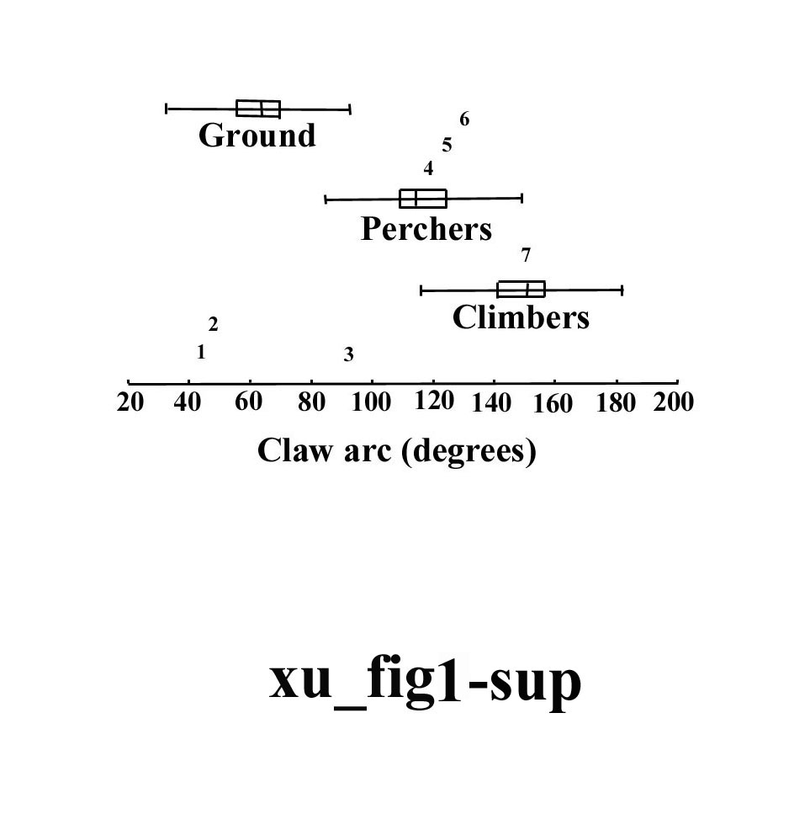
Figure 1 Box and whiskers plot of pedal claw (III) arc measurements for extant ground, perching, and climbing birds, and selected non-avian theropods and early birds (modified from Fig. 2 of ref. 6). In this analysis we include only those fossil taxa that have the horny sheath preserved. Abbreviations: 1, Compsognathus; 2, Caudipteryx; 3, Sinornithosaurus; 4, Archaeopteryx; 5, Confuciusornis; 6, Sinornis; 7, Microraptor.

